Automated Driving
System (ADS)

By Thiwanka Reiss

Summary
(100-200 words)

Table of Contents
Summary 1
Table of Contents 1
1 Introduction 2
2 Theory 2
3 Material and methods 2
4 Observations 2
5 Analysis and results 2
6 Discussion 2
7 Conclusions 2
8 References 2
Appendices 2

CAN Bus implementation (Controller Area network)
FS-AI_API has been, as a reference for teams to start implementing their vehicle interface code.
After inspection of the API we were able to identify that this code was written on a Linux based system and socket can have been used, but we are planning to use a NUCLEO L037RZ (STM32) as the low-level micro controller which do not support Linux, it supports bare-metal C/C++.
Data frames and program structure in the code was identified and changed to work for our use case in the NUCLEO L037.
Here our focus is sending data to the VCU from API and receiving data from VCU to the API.
Some the Data frames that were identified and added to Readme file of our repository is shown below. (Note that code is fully implemented, some data frames is yet to be added to the ReadMe file)
Repository: - https://github.com/FalconE-Racing/DV_Real.git
Data frames Used to Communicate from the Api to VCU (User side - Set Method)
Frame Id | Frame Use
0x510 | VCU status
0x511 | Drive Forward
0x512 | Drive Rear
0x513 | Steering
0x514 | Brake

Note that the bits in a byte are numbered from zero to seven
VCU Status
Frame Id:- 0x510
DLC :- 8
Byte | Signal | Description
data0 | Hand shake bit | Only the 0th bit is used where, 1 = bit recived , 0 = bit not received
data1 | Dirrection , mission and stop request | 6 th bit , 1 = Forward , 0 = Neutral
 |  | 5th, 4th bit , 0 = Mission not selected, 1 = Mission selected, 2 = Mission Running, 3 = Mission Finished
 |  | 0th bit , 0 = Emenrgency Stop No , 1 = Emergency Stop Yes
data2 | Lap Counter | 0th to 3rd bit , maximum of 15 laps is expected
data3 | Cone Count | Expecting value from 0 - 255
data4 | Total Cone Count | 0th to 7th bits of Total cone count
data5 | TOtal Cone Count | 8th to 17th bit of Total cone count

Drive Forward
Frame Id:- 0x511
DLC :- 4
Byte | Signal | Description
data0 | Front Axel Torque Request | 0th to 7th bits of Torque Request
data1 | Front Axel Torque Request | 8th to 15th bits of Torque Request
data2 | Front Axel Motor Speed Request | 0th to 7th bits of Motor Speed Request
data3 | Front Axel Motor Speed Request | 8th to 15th bits of Motor Speed Request

Drive Rear
Frame Id:- 0x512
DLC :- 4
Byte | Signal | Description
data0 | Rear Axel Torque Request | 0th to 7th bits of Torque Request
data1 | Rear Axel Torque Request | 8th to 15th bits of Torque Request
data2 | Rear Axel Motor Speed Request | 0th to 7th bits of Motor Speed Request
data3 | Rear Axel Motor Speed Request | 8th to 15th bits of Motor Speed Request

Steering
Frame Id:- 0x513
DLC :- 2
Byte | Signal | Description
data0 | Steer Angle Request | 0th to 7th bits of Steer Angle Request
data1 | Steer Angle Request | 8th to 15th bits of Steer Angle Request

Brake
Frame Id:- 0x514
DLC :- 2
Byte | Signal | Description
data0 | Forward Pressure Required | Expecting value from 0 - 255
data1 | Rear Pressure Required | Expecting value from 0 - 255

Data frames Used to Communicate from the VCU to Api (User side - Get Method)
Frame Id | Frame Use
0x520 | VCU status
0x521 | Drive Forward
0x522 | Drive Rear
0x523 | Steering
0x524 | Brake
0x525 | Wheel Speed
0x526 | Wheel Count
VCU Status
Frame Id:- 0x520
DLC :- 3
Byte | Signal | Description
data0 | Hand shake bit | Only the 0th bit is used where, 1 = bit recived , 0 = bit not received
data1 | Ready to GO Signal | 3rd bit, 1 = Ready to Go, 0 = Not Ready to Go
data2 | Autonomous State (AS) | 0th to 3rd bit is used , five states are present
 |  | 1 - Off/ Manual
 |  | 2 - Ready
 |  | 3 - Driving
 |  | 4 - Emergency Brake
 |  | 5 - Finished
 | Autonomous Mission Indicator (AMI) | 4th to 7th bit , seven states are present
 |  | 0 - AMI Not Selected
 |  | 1 - AMI Accelleration
 |  | 2 - AMI Skidpad
 |  | 3 - AMI Autocross
 |  | 4 - AMI Trackdrive
 |  | 5 - AMI Static Inspection A
 |  | 6 - AMI Static Inspection B
 |  | 7 - AMI Autonomous Demo

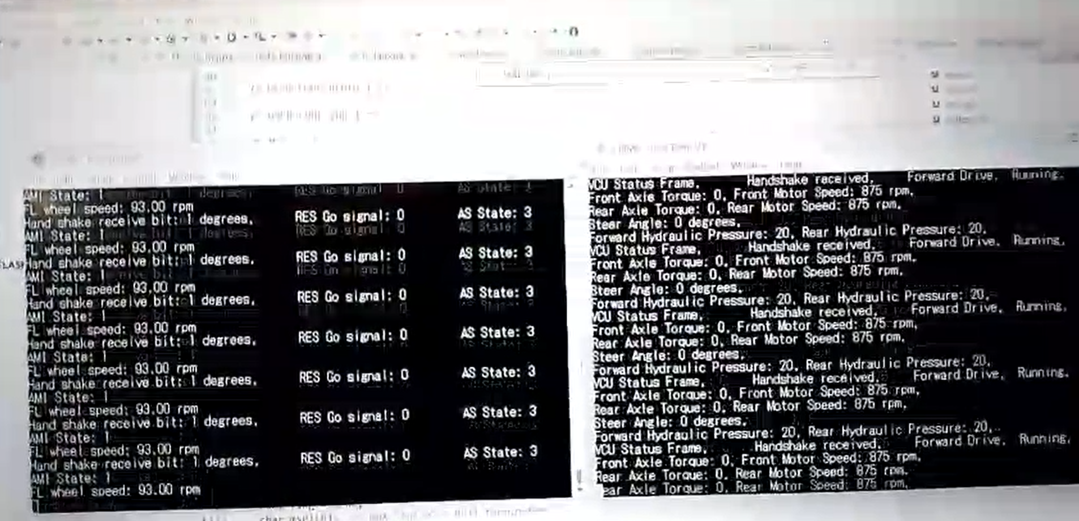
Designing smaller four-wheel robot for testing out the driverless stack.
To test out our code we are planning to implement a smaller four-wheel robot. A steering system was developed for the robot. Some calculations were done regarding the mechanism using python.
Wheel base = 20cm
Distance between front and rear axel = 22.22cm
Maximum steering angle = 40.1 deg
Distance from mid-point of read axel to mean of canters of rotation =30cm
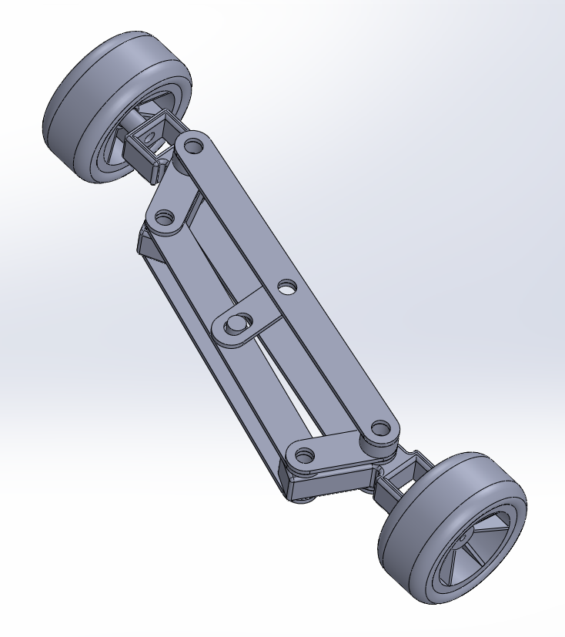

Calculating maximum steer angle, centre of rotation and other parameters required for the design.
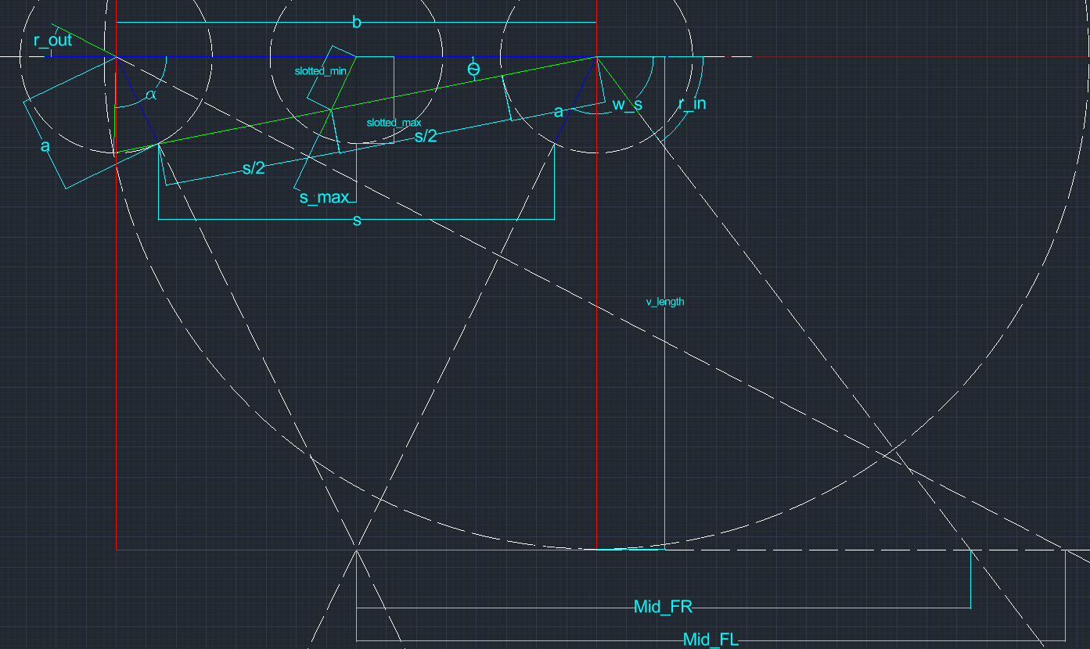
$$\text{Slotted Level Max Length}=slotted_max=\sqrt{a^{2}-{\left(\frac{b-s}{2}\right)}^{2}}$$
$$⁡θ=\cos^{-1}{\frac{b^{2}+(s+a)^{2}-a^{2}}{2⋅b⋅(s+a)}}$$
$$\text{Slotted Level Min Length}\text{ = }\text{slotted_min}=\sqrt{{\left(\frac{b}{2}\right)}^{2}+{\left(\frac{s}{2} + a\right)}^{2}-2⋅\frac{b}{2}⋅\left(\frac{s}{2} + a\right)⋅cos⁡θ}$$
$$\text{Max Steering Angle}=\cos^{-1}\left(\frac{{\left(\frac{b}{2}\right)}^{2}+(\text{slotted_min})^{2}-{\left(\frac{s}{2} + a\right)}^{2}}{2⋅\frac{b}{2}⋅\text{slotted_min}}\right)-90$$
$$\text{Vehicle Length}=v_length =\frac{a⋅b}{b-s}$$
$$180-w_s=\cos^{-1}\left(\frac{b-s}{2a}\right)⁡$$
$$w_s=180-\cos^{-1}\left(\frac{b-s}{2a}\right)$$
$$\text{r_in}=(180-w_s)-θ$$
$$α=\cos^{-1}\left(\frac{b^{2}-(s+a)^{2}+a^{2}}{2⋅b⋅a}\right)$$
$$\text{r_out}=α-(180-w_s)$$
$$Mid_FL=\left(\frac{\text{v_length}}{\tan\left(r_{out}\right)}\right)-\frac{b}{2}$$
$$Mid_FR=\left(\frac{\text{v}\text{_length}}{tan⁡(r_in)}\right)+\frac{b}{2}$$
$$Average= \frac{Mid_FL+ Mid_FR}{2}$$

SolidWorks Simulation
Steering angle vs Iner front wheel.
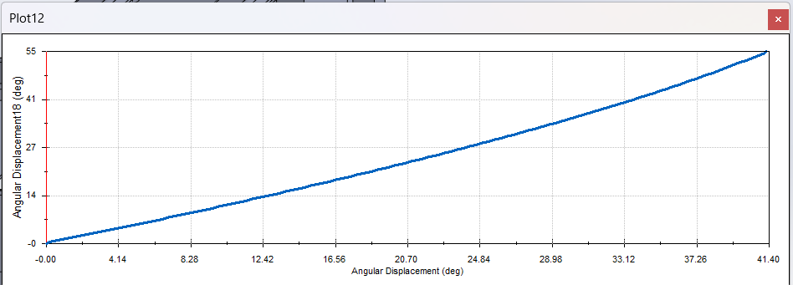
Steering angle vs Outer front wheel.
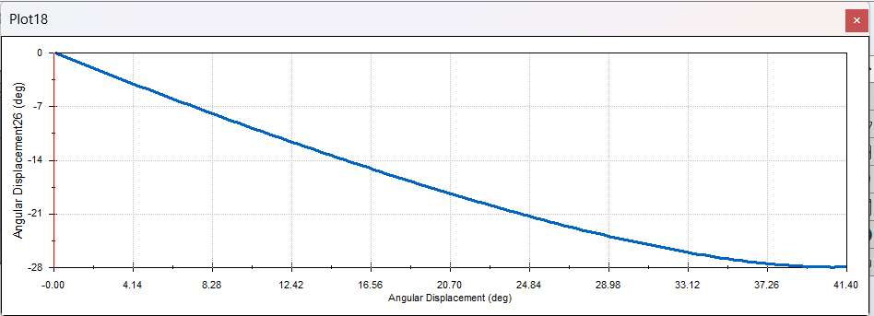
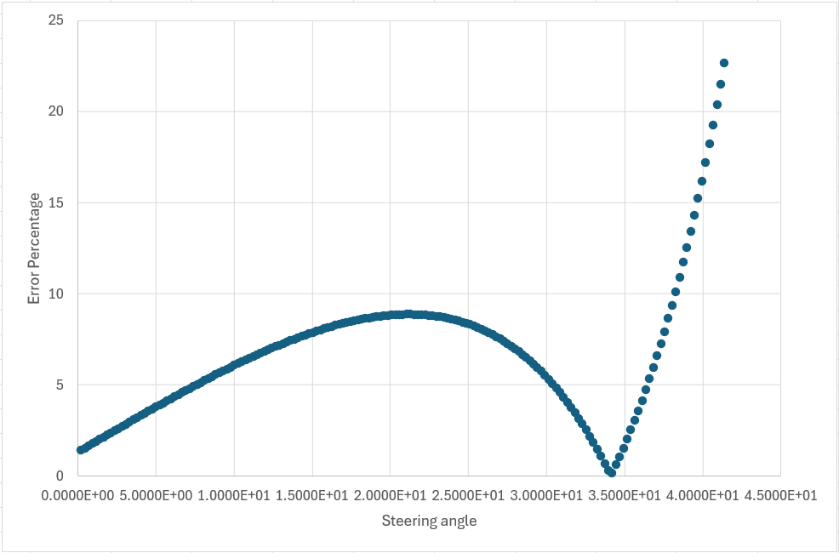
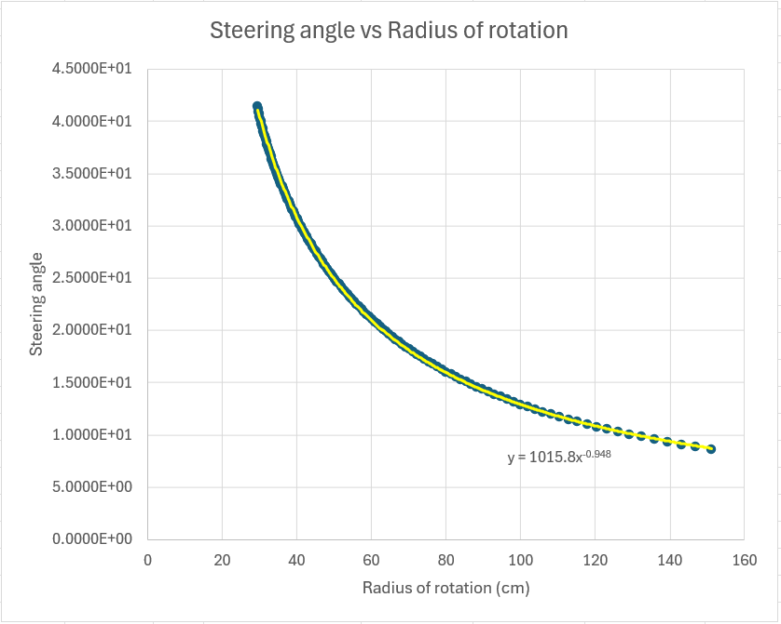
Solid works data
Steering Angle (deg) | Outer wheel angle (deg) | Inner Wheel Angle (deg)
Ref. Coordinate System: | Ref. Coordinate System: | Ref. Coordinate System:
-1.2762E-14 | 5.1659E-11 | -2.8010E-11
2.3931E-01 | -2.4055E-01 | 2.3806E-01
4.7861E-01 | -4.8051E-01 | 4.7671E-01
7.1792E-01 | -7.1988E-01 | 7.1595E-01
9.5723E-01 | -9.5867E-01 | 9.5578E-01
1.1965E+00 | -1.1969E+00 | 1.1962E+00
1.4358E+00 | -1.4345E+00 | 1.4372E+00
1.6751E+00 | -1.6715E+00 | 1.6788E+00
1.9145E+00 | -1.9079E+00 | 1.9210E+00
2.1538E+00 | -2.1437E+00 | 2.1638E+00
2.3931E+00 | -2.3790E+00 | 2.4072E+00
2.6324E+00 | -2.6136E+00 | 2.6511E+00
2.8717E+00 | -2.8477E+00 | 2.8957E+00
3.1110E+00 | -3.0811E+00 | 3.1408E+00
3.3503E+00 | -3.3140E+00 | 3.3866E+00
3.5896E+00 | -3.5463E+00 | 3.6329E+00
3.8289E+00 | -3.7780E+00 | 3.8798E+00
4.0682E+00 | -4.0091E+00 | 4.1274E+00
4.3075E+00 | -4.2395E+00 | 4.3755E+00
4.5468E+00 | -4.4694E+00 | 4.6242E+00
4.7861E+00 | -4.6987E+00 | 4.8736E+00
5.0254E+00 | -4.9274E+00 | 5.1235E+00
5.2647E+00 | -5.1555E+00 | 5.3740E+00
5.5040E+00 | -5.3829E+00 | 5.6252E+00
5.7434E+00 | -5.6098E+00 | 5.8769E+00
5.9827E+00 | -5.8361E+00 | 6.1293E+00
6.2220E+00 | -6.0617E+00 | 6.3822E+00
6.4613E+00 | -6.2868E+00 | 6.6358E+00
6.7006E+00 | -6.5112E+00 | 6.8900E+00
6.9399E+00 | -6.7350E+00 | 7.1448E+00
7.1792E+00 | -6.9582E+00 | 7.4002E+00
7.4185E+00 | -7.1808E+00 | 7.6563E+00
7.6578E+00 | -7.4027E+00 | 7.9129E+00
7.8971E+00 | -7.6240E+00 | 8.1702E+00
8.1364E+00 | -7.8447E+00 | 8.4282E+00
8.3757E+00 | -8.0648E+00 | 8.6867E+00
8.6150E+00 | -8.2842E+00 | 8.9459E+00
8.8543E+00 | -8.5030E+00 | 9.2057E+00
9.0936E+00 | -8.7211E+00 | 9.4662E+00
9.3329E+00 | -8.9387E+00 | 9.7273E+00
9.5723E+00 | -9.1555E+00 | 9.9891E+00
9.8116E+00 | -9.3717E+00 | 1.0251E+01
1.0051E+01 | -9.5873E+00 | 1.0515E+01
1.0290E+01 | -9.8022E+00 | 1.0778E+01
1.0529E+01 | -1.0016E+01 | 1.1043E+01
1.0769E+01 | -1.0230E+01 | 1.1308E+01
1.1008E+01 | -1.0443E+01 | 1.1573E+01
1.1247E+01 | -1.0655E+01 | 1.1840E+01
1.1487E+01 | -1.0867E+01 | 1.2107E+01
1.1726E+01 | -1.1078E+01 | 1.2374E+01
1.1965E+01 | -1.1288E+01 | 1.2643E+01
1.2205E+01 | -1.1497E+01 | 1.2912E+01
1.2444E+01 | -1.1706E+01 | 1.3182E+01
1.2683E+01 | -1.1914E+01 | 1.3452E+01
1.2923E+01 | -1.2122E+01 | 1.3723E+01
1.3162E+01 | -1.2328E+01 | 1.3995E+01
1.3401E+01 | -1.2535E+01 | 1.4268E+01
1.3640E+01 | -1.2740E+01 | 1.4541E+01
1.3880E+01 | -1.2944E+01 | 1.4815E+01
1.4119E+01 | -1.3148E+01 | 1.5090E+01
1.4358E+01 | -1.3351E+01 | 1.5366E+01
1.4598E+01 | -1.3554E+01 | 1.5642E+01
1.4837E+01 | -1.3755E+01 | 1.5919E+01
1.5076E+01 | -1.3956E+01 | 1.6197E+01
1.5316E+01 | -1.4156E+01 | 1.6475E+01
1.5555E+01 | -1.4356E+01 | 1.6754E+01
1.5794E+01 | -1.4554E+01 | 1.7034E+01
1.6034E+01 | -1.4752E+01 | 1.7315E+01
1.6273E+01 | -1.4949E+01 | 1.7597E+01
1.6512E+01 | -1.5145E+01 | 1.7879E+01
1.6751E+01 | -1.5341E+01 | 1.8162E+01
1.6991E+01 | -1.5535E+01 | 1.8446E+01
1.7230E+01 | -1.5729E+01 | 1.8731E+01
1.7469E+01 | -1.5922E+01 | 1.9017E+01
1.7709E+01 | -1.6114E+01 | 1.9303E+01
1.7948E+01 | -1.6306E+01 | 1.9591E+01
1.8187E+01 | -1.6496E+01 | 1.9879E+01
1.8427E+01 | -1.6686E+01 | 2.0168E+01
1.8666E+01 | -1.6875E+01 | 2.0457E+01
1.8905E+01 | -1.7063E+01 | 2.0748E+01
1.9145E+01 | -1.7250E+01 | 2.1040E+01
1.9384E+01 | -1.7436E+01 | 2.1332E+01
1.9623E+01 | -1.7621E+01 | 2.1626E+01
1.9862E+01 | -1.7805E+01 | 2.1920E+01
2.0102E+01 | -1.7989E+01 | 2.2215E+01
2.0341E+01 | -1.8171E+01 | 2.2511E+01
2.0580E+01 | -1.8353E+01 | 2.2808E+01
2.0820E+01 | -1.8533E+01 | 2.3106E+01
2.1059E+01 | -1.8713E+01 | 2.3405E+01
2.1298E+01 | -1.8892E+01 | 2.3705E+01
2.1538E+01 | -1.9069E+01 | 2.4006E+01
2.1777E+01 | -1.9246E+01 | 2.4308E+01
2.2016E+01 | -1.9422E+01 | 2.4611E+01
2.2255E+01 | -1.9596E+01 | 2.4915E+01
2.2495E+01 | -1.9770E+01 | 2.5220E+01
2.2734E+01 | -1.9942E+01 | 2.5526E+01
2.2973E+01 | -2.0114E+01 | 2.5833E+01
2.3213E+01 | -2.0284E+01 | 2.6142E+01
2.3452E+01 | -2.0454E+01 | 2.6451E+01
2.3691E+01 | -2.0622E+01 | 2.6761E+01
2.3931E+01 | -2.0789E+01 | 2.7073E+01
2.4170E+01 | -2.0955E+01 | 2.7385E+01
2.4409E+01 | -2.1120E+01 | 2.7699E+01
2.4649E+01 | -2.1283E+01 | 2.8014E+01
2.4888E+01 | -2.1446E+01 | 2.8330E+01
2.5127E+01 | -2.1607E+01 | 2.8648E+01
2.5366E+01 | -2.1767E+01 | 2.8966E+01
2.5606E+01 | -2.1926E+01 | 2.9286E+01
2.5845E+01 | -2.2084E+01 | 2.9607E+01
2.6084E+01 | -2.2240E+01 | 2.9929E+01
2.6324E+01 | -2.2395E+01 | 3.0253E+01
2.6563E+01 | -2.2549E+01 | 3.0578E+01
2.6802E+01 | -2.2701E+01 | 3.0904E+01
2.7042E+01 | -2.2852E+01 | 3.1232E+01
2.7281E+01 | -2.3002E+01 | 3.1561E+01
2.7520E+01 | -2.3150E+01 | 3.1891E+01
2.7760E+01 | -2.3297E+01 | 3.2223E+01
2.7999E+01 | -2.3442E+01 | 3.2556E+01
2.8238E+01 | -2.3586E+01 | 3.2891E+01
2.8477E+01 | -2.3729E+01 | 3.3227E+01
2.8717E+01 | -2.3870E+01 | 3.3565E+01
2.8956E+01 | -2.4009E+01 | 3.3904E+01
2.9195E+01 | -2.4147E+01 | 3.4245E+01
2.9435E+01 | -2.4283E+01 | 3.4587E+01
2.9674E+01 | -2.4418E+01 | 3.4931E+01
2.9913E+01 | -2.4551E+01 | 3.5277E+01
3.0153E+01 | -2.4682E+01 | 3.5624E+01
3.0392E+01 | -2.4811E+01 | 3.5973E+01
3.0631E+01 | -2.4939E+01 | 3.6324E+01
3.0871E+01 | -2.5065E+01 | 3.6676E+01
3.1110E+01 | -2.5189E+01 | 3.7031E+01
3.1349E+01 | -2.5312E+01 | 3.7387E+01
3.1588E+01 | -2.5432E+01 | 3.7745E+01
3.1828E+01 | -2.5551E+01 | 3.8105E+01
3.2067E+01 | -2.5668E+01 | 3.8467E+01
3.2306E+01 | -2.5782E+01 | 3.8831E+01
3.2546E+01 | -2.5895E+01 | 3.9197E+01
3.2785E+01 | -2.6005E+01 | 3.9565E+01
3.3024E+01 | -2.6114E+01 | 3.9936E+01
3.3264E+01 | -2.6220E+01 | 4.0308E+01
3.3503E+01 | -2.6324E+01 | 4.0683E+01
3.3742E+01 | -2.6425E+01 | 4.1060E+01
3.3982E+01 | -2.6525E+01 | 4.1439E+01
3.4221E+01 | -2.6622E+01 | 4.1821E+01
3.4460E+01 | -2.6717E+01 | 4.2205E+01
3.4699E+01 | -2.6809E+01 | 4.2591E+01
3.4939E+01 | -2.6898E+01 | 4.2980E+01
3.5178E+01 | -2.6985E+01 | 4.3372E+01
3.5417E+01 | -2.7070E+01 | 4.3766E+01
3.5657E+01 | -2.7151E+01 | 4.4163E+01
3.5896E+01 | -2.7230E+01 | 4.4563E+01
3.6135E+01 | -2.7306E+01 | 4.4965E+01
3.6375E+01 | -2.7379E+01 | 4.5371E+01
3.6614E+01 | -2.7449E+01 | 4.5779E+01
3.6853E+01 | -2.7516E+01 | 4.6191E+01
3.7092E+01 | -2.7580E+01 | 4.6606E+01
3.7332E+01 | -2.7641E+01 | 4.7024E+01
3.7571E+01 | -2.7698E+01 | 4.7445E+01
3.7810E+01 | -2.7752E+01 | 4.7870E+01
3.8050E+01 | -2.7802E+01 | 4.8298E+01
3.8289E+01 | -2.7849E+01 | 4.8730E+01
3.8528E+01 | -2.7892E+01 | 4.9165E+01
3.8768E+01 | -2.7931E+01 | 4.9605E+01
3.9007E+01 | -2.7967E+01 | 5.0048E+01
3.9246E+01 | -2.7998E+01 | 5.0496E+01
3.9486E+01 | -2.8025E+01 | 5.0947E+01
3.9725E+01 | -2.8048E+01 | 5.1403E+01
3.9964E+01 | -2.8066E+01 | 5.1863E+01
4.0203E+01 | -2.8080E+01 | 5.2328E+01
4.0443E+01 | -2.8089E+01 | 5.2798E+01
4.0682E+01 | -2.8093E+01 | 5.3272E+01
4.0921E+01 | -2.8092E+01 | 5.3752E+01
4.1161E+01 | -2.8086E+01 | 5.4236E+01
4.1400E+01 | -2.8075E+01 | 5.4726E+01

